Documentation

Mario Calleja Ahijado

Kutman Eshenkulov

Rafael Gil López

Grado en Ciencia de Datos

Big Data Project

Content Table

Create a GitHub repo to which all the teammates have access, and subsequently all of the git projects in each of your laptop. 3

Web Scraping 3

We have used roboflow to label the images, use data augmentation and train a model. 4

Hugging Face 6

# Create a GitHub repo to which all the teammates have access, and subsequently all of the git projects in each of your laptop.

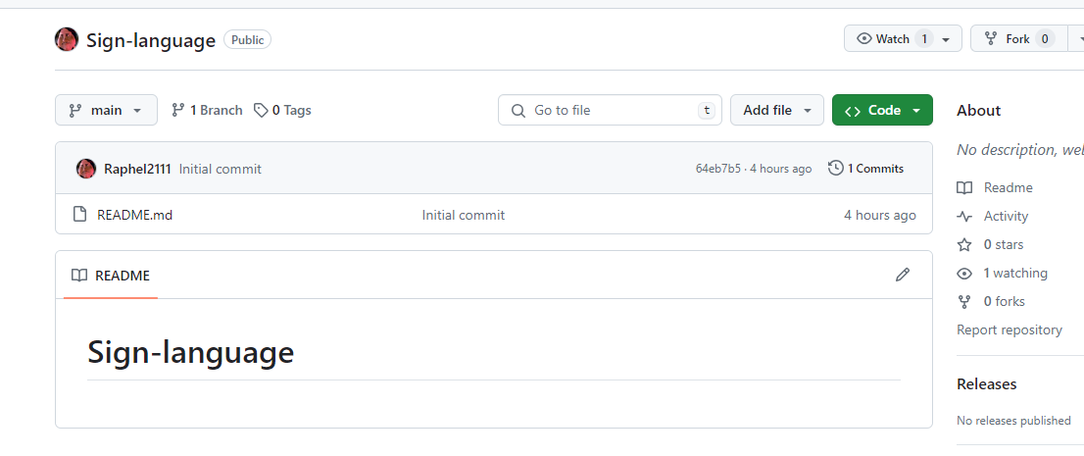

# Web Scraping

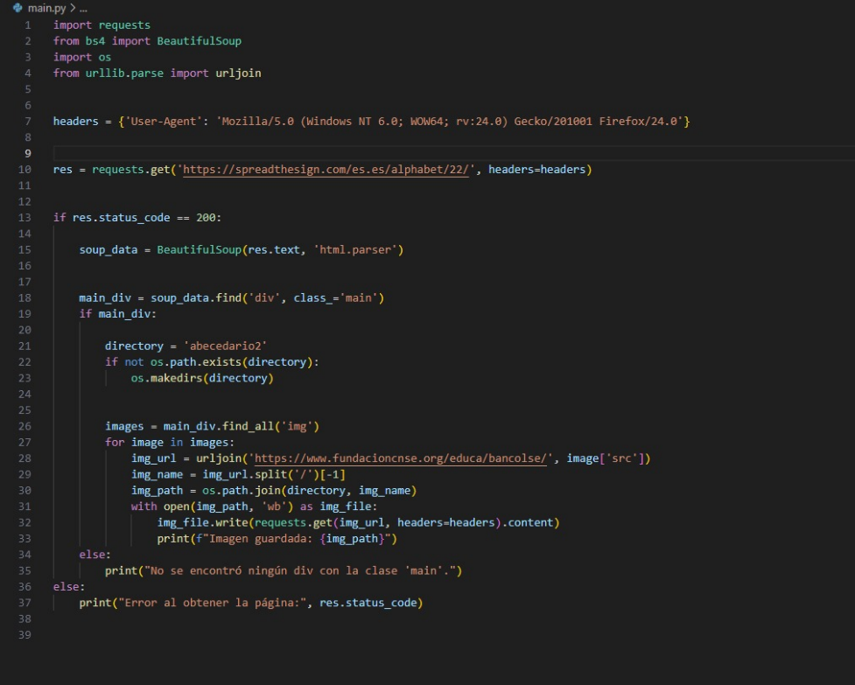

**Figure 1 Web Scraping**

# We have used roboflow to label the images, use data augmentation and train a model.

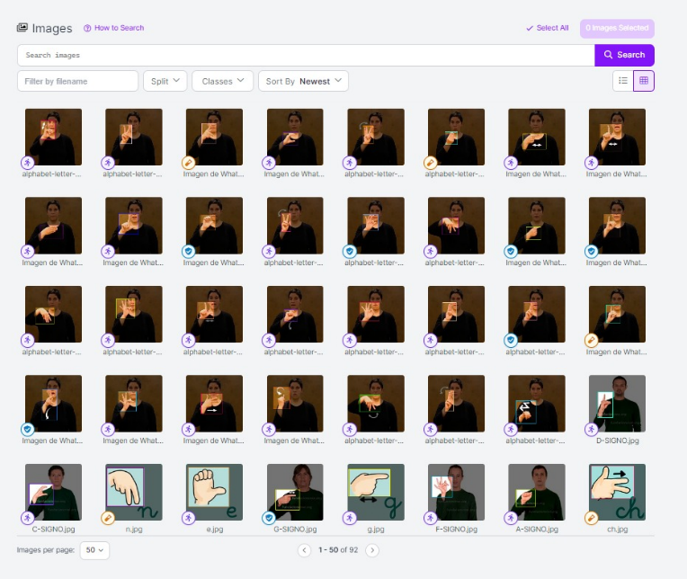

**Figure 2 Image tagging**

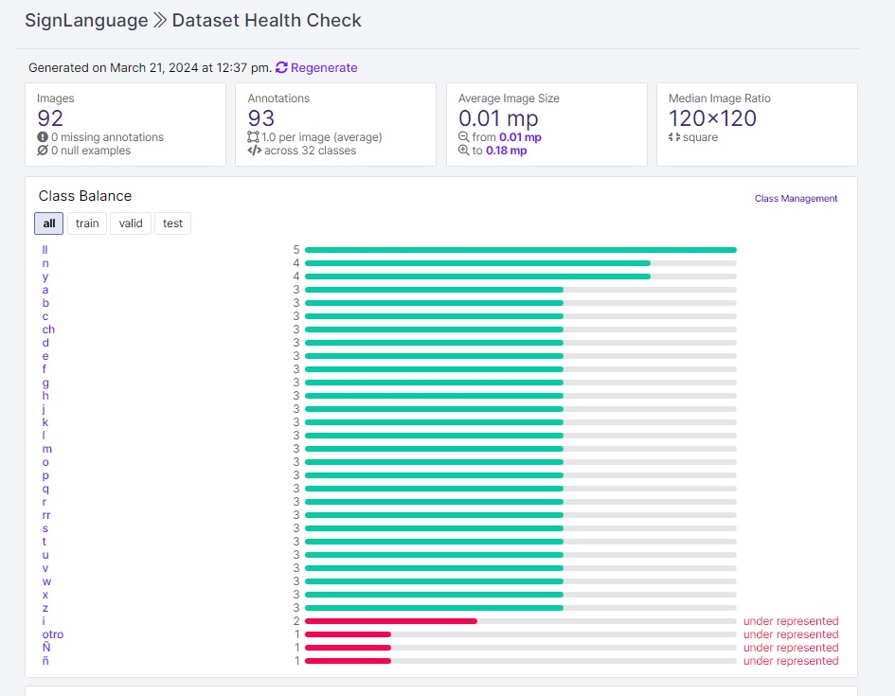

**Figure 3 Number of images per letter**

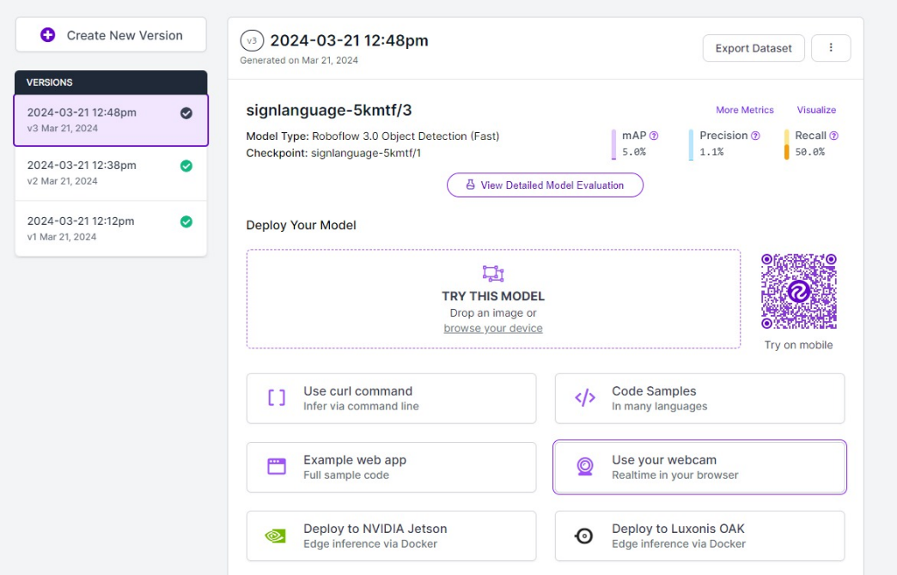

**Figure 4 Trained model**

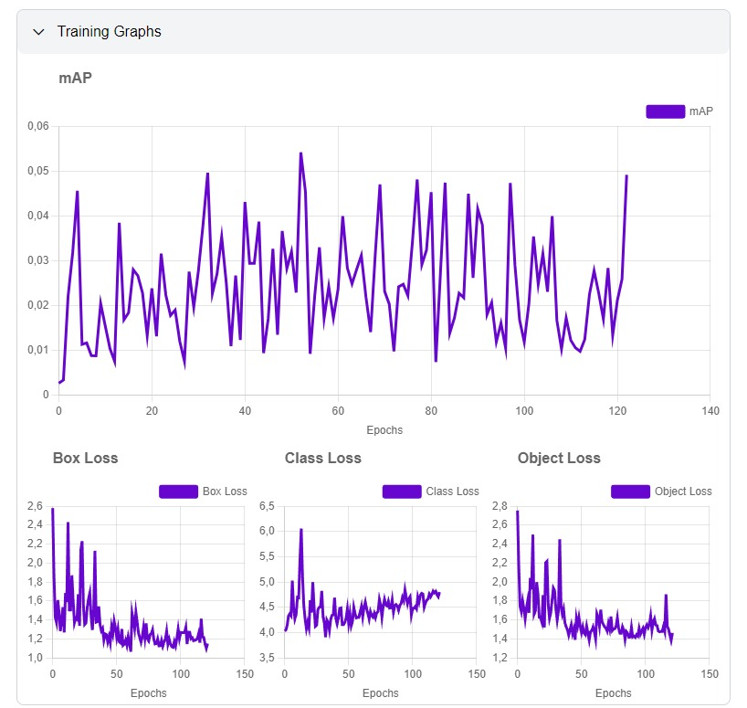

**Figure 5 Training Graphs**

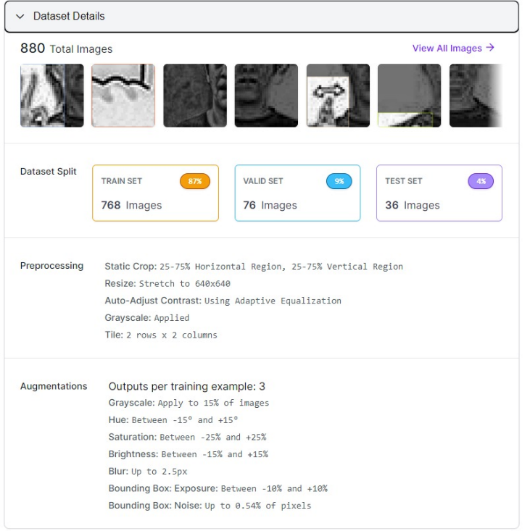

**Figure 6 Data Augmentation**

# Hugging Face

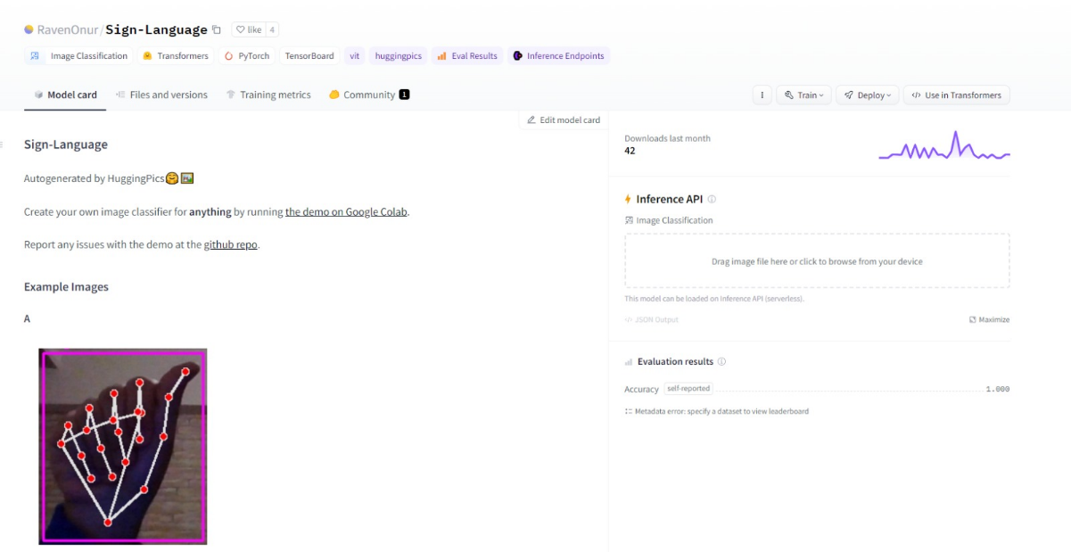

**Figure 7 Hugging face model**

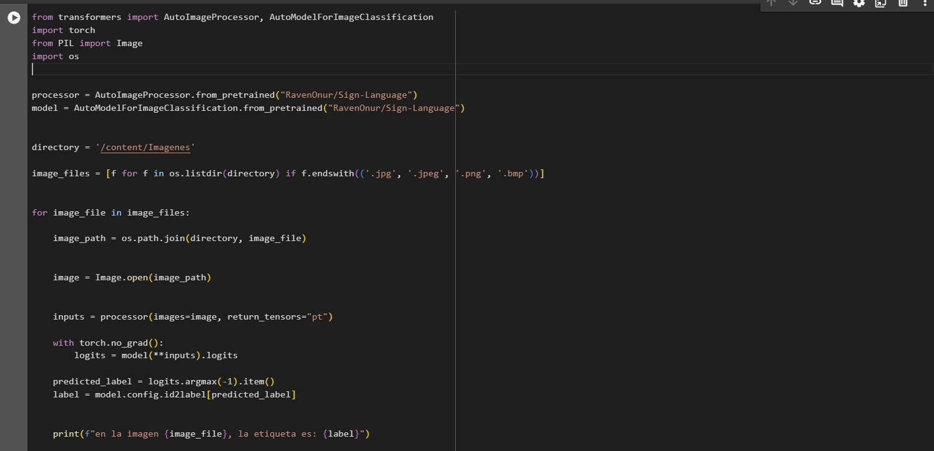

**Figure 8 model**

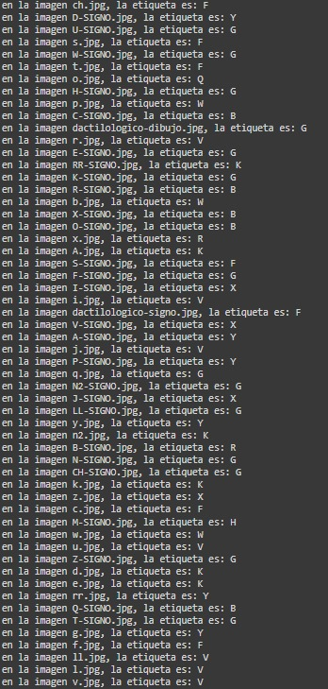

**Figure 9 output**

The fact that the model cannot classify the images well is due to the fact that the images with which it has been trained have had prior preprocessing which has caused the model to have learned to detect patterns and images with white borders and where only hand. The images used to test it are in colors, with a different background, size and the isolated hand does not appear.